

|  |  |
| --- | --- |
| Name | Aryan Dilipbhai Langhanoja |
| Roll No | 92200133030 |

Problems

**1-8. Obtain the I's and 2's complement of the following binary numbers: 1010101, 0111000, 0000001. 10000, 00000.**

**Ans:-**

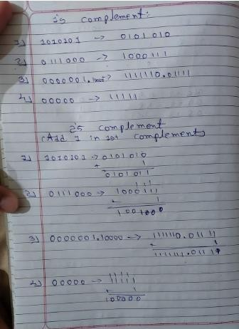

**1-9. Obtain the 9's and 10's complement of the following decimal numbers: 13579,09900, 90090, 10000**

**Ans:-**

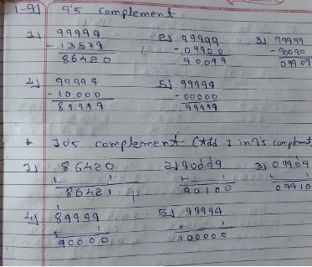

**1-10. Find the 10's complement of (935),, Ans:-**

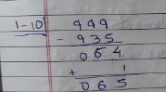

**1-11. Perform the subtraction with the following decimal numbers using (1) 10's complement and (2) 9's complement. Check the answer by straight subtraction.**

**(e) 5250-321**

**(f) 3570-2100**

**(c) 753-864**

**(d) 20-1000**

**Ans:-**

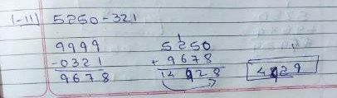

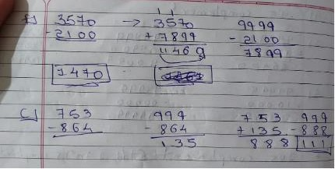

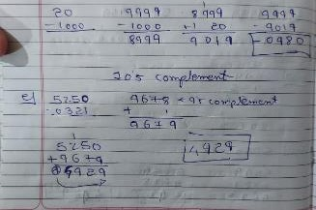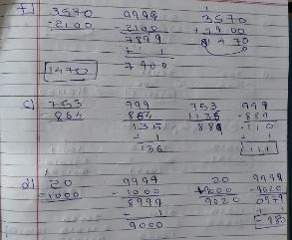

**1-12. Perform the subtraction with the following binary numbers using (1) 2's complement and (2) I's complement. Check the answer by straight subtraction.**

**(a) 11010-1101**

**(c) 1001010011**

**(d) 100-110000**

**(b) 11010-10000**

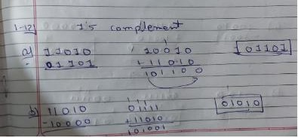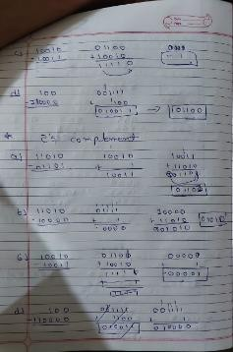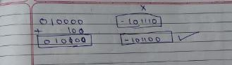

**1-13. Prove the procedure stated in Sec. 1-5 for the subtraction of two numbers with (r-I)'s complement.**

**Ans:-**

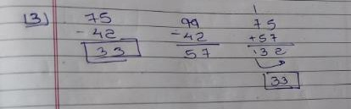

Step 1: Find the (r-1)'s complement of the number being subtracted (42).

To find the 9's complement of 42, we subtract each digit from 9: 9 - 4 = 5 and 9

- 2 = 7. Therefore, the 9's complement of 42 is 57.

Step 2: Add the (r-1)'s complement to the minuend (75). Therefore, 75 minus 42 is equal to 33

**1-14. For the weighted codes (a) 3, 3, 2, 1 and (b) 4, 4, 3,- 2 for the decimal digits, determine all possible tables so that the 9's complement of each decimal digit is obtained by changing I's to O's and 0's to 1's.**

**Ans:-**

a) For the weighted code 3, 3, 2, 1:

Let's consider each decimal digit in turn:

For digit 0, the 9's complement is 9. The binary equivalent of 9 is 1001. To obtain the 9's complement by changing 1's to 0's and 0's to 1's, we need to change the 1's in the binary equivalent to 0's and the 0's to 1's, giving 0110. This means that the code for 0 is 0110.

For digit 1, the 9's complement is 8. The binary equivalent of 8 is 1000. To obtain the 9's complement by changing 1's to 0's and 0's to 1's, we need to change the 1's in the binary equivalent to 0's and the 0's to 1's, giving 0111. This means that the code for 1 is 0111.

For digit 2, the 9's complement is 7. The binary equivalent of 7 is 0111. To obtain the 9's complement by changing 1's to 0's and 0's to 1's, we need to change the 1's in the binary equivalent to 0's and the 0's to 1's, giving 1000. This means that the code for 2 is 1000.

For digit 3, the 9's complement is 6. The binary equivalent of 6 is 0110. To obtain the 9's complement by changing 1's to 0's and 0's to 1's, we need to change the 1's in the binary equivalent to 0's and the 0's to 1's, giving 1001. This means that the code for 3 is 1001.

Therefore, the possible codes that satisfy the given condition are 0110, 0111, 1000, and 1001.

B)

Let's consider each decimal digit in turn:

For digit 0, the 9's complement is 9. The binary equivalent of 9 is 1001. To obtain the 9's complement by changing 1's to 0's and 0's to 1's, we need to change the 1's in the binary equivalent to 0's and the 0's to 1's, giving 0110. This means that the code for 0 is 0110.

For digit 1, the 9's complement is 8. The binary equivalent of 8 is 1000. To obtain the 9's complement by changing 1's to 0's and 0's to 1's, we need to change the 1's in the binary equivalent to 0's and the 0's to 1's, giving 0111. This means that the code for 1 is 0111.

For digit 2, the 9's complement is 7. The binary equivalent of 7 is 0111. To obtain the 9's complement by changing 1's to 0's and 0's to 1's, we need to change the 1's in the binary equivalent to 0's and the 0's to 1's, giving 1000. This means that the code for 2 is 1000.

For digit 3, the 9's complement is 6. The binary equivalent of

**1-31. Perform (-44),,- (67),, using 10's complement method Ans:-** 